|  |  |  |  |  |  |
| --- | --- | --- | --- | --- | --- |
| Date | 7-Dec-22 | | | Tester Name | Mohammad Yusuf |
| Environment | Penfax - Test | | | Login used |  |
| Operating System | Select OS | Version: | Update: | | |
| Software Used | Select Software | Version: | Update: | | |
| Select Software | Version: | Update: | | |
| Release version |  | | | | |
| Title | M17 Contributions & DCT | | | | |
| Test Type | Regression | | | | |
| Test Scenario | M17.23 Updating Security Questions | | | | |
|  |  | | | | |
| Expected Results | Password and User Name should be recovered using Security Questions. | | | | |
| Pass/Fail | Pass | | | JIRA# | N/A |

Describe your steps with screenshots:

1. Log in to MEPP DCT and click on Profile.

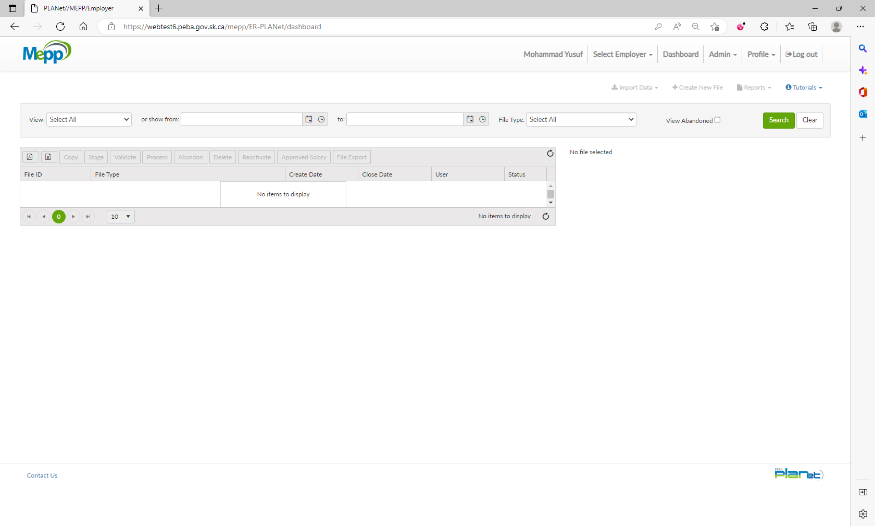

1. Click on Security Questions.

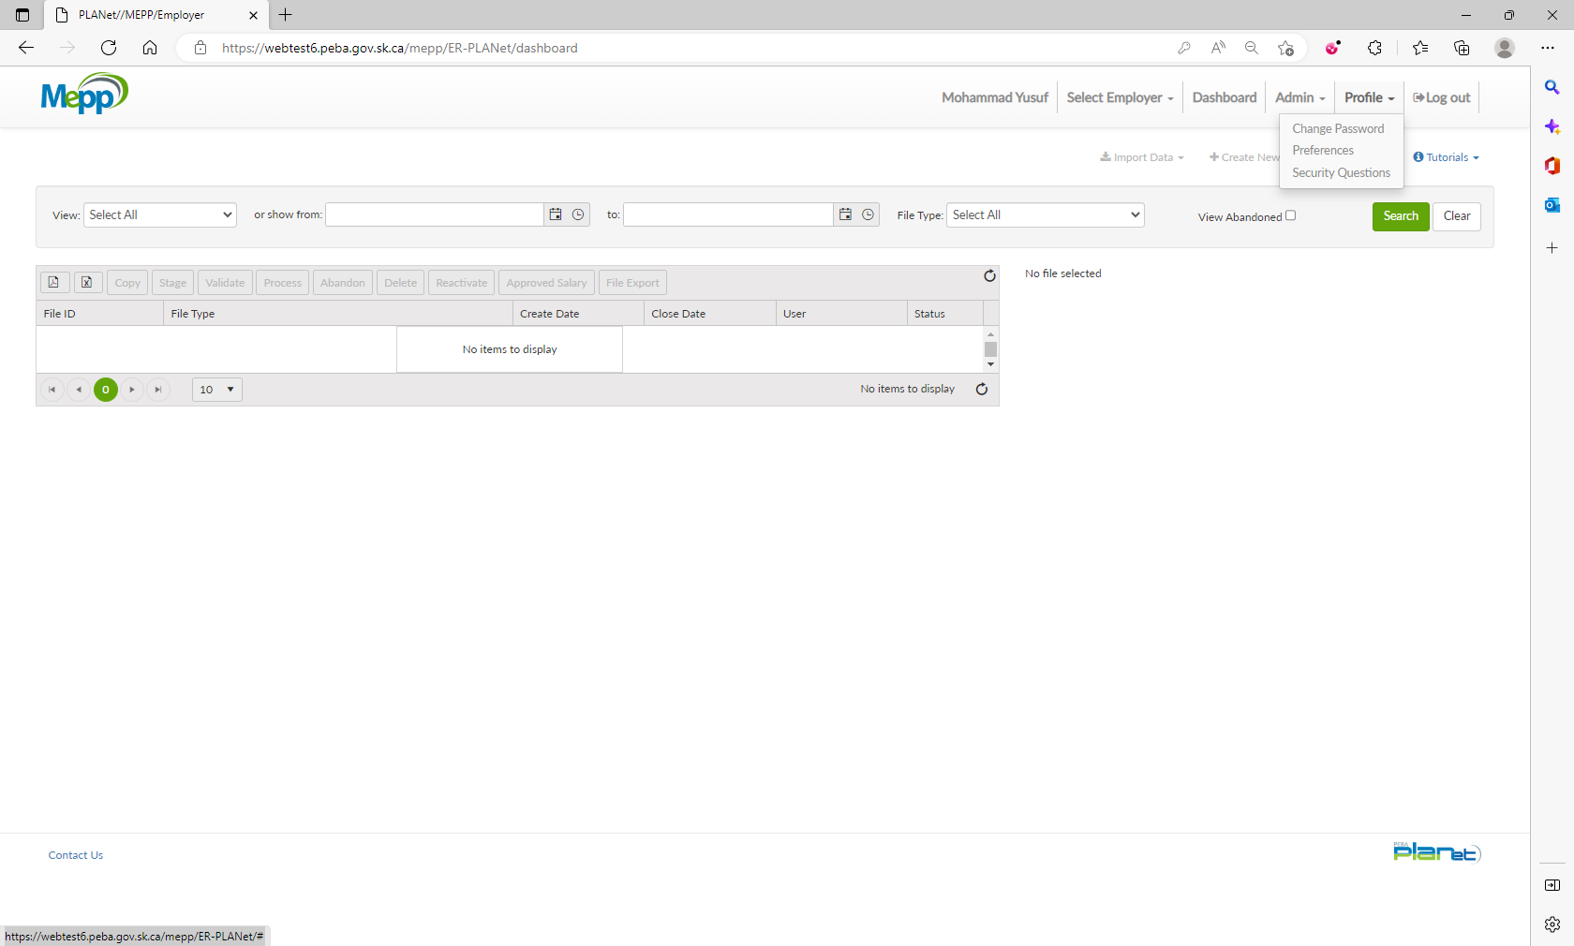

1. Select new questions from the dropdown, update your answers and then click Submit.

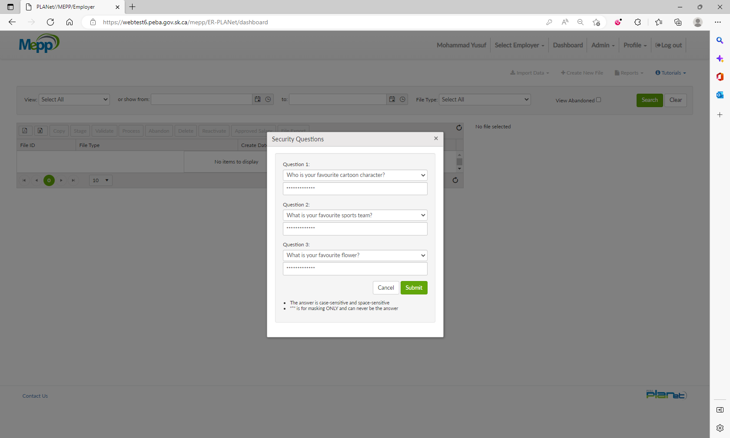

1. You will get the notification.

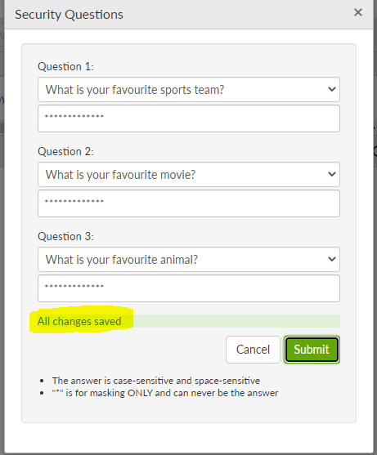

1. Try to recover your password or username using new Security Questions.